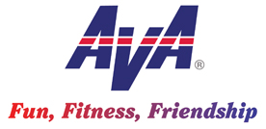
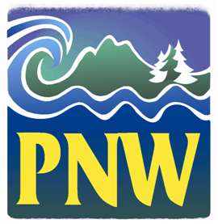
Hello NW Volkssporters!

1. Delegate Forms. Just a final reminder to ensure your club’s convention delegate designation forms have been submitted.

2. Convention Registration. If you’ve been holding off on your convention registration please do it soon. As usual, the registrations are starting slow, but our planners need to get a reasonable count of participants to ensure adequate support for the many events. The convention information on the AVA website is getting more complete, so keep checking for the details of all the great activities planned for your enjoyment.

3. Convention Workshops. For convention attendees we have an exciting lineup of workshops. Presentations range from America Walks, a national promoter of community walkability; GroupWorks, our online club communications provider; experts on the various historic walk venues; and a number of club support related topics. The presenters are excited to deliver their information and I hope all our attendees will make a special effort to audit as many lectures as possible. Delegates should especially attend the business-related workshops to gain information for your clubs and share your perspectives.

4. Winter Challenge. Good luck in the prize drawings to all who participated in this fun winter inspiration to get out walking no matter the weather. Be sure to submit your tracking sheets to Ed Hainline in the next 10 days or so. I want to mention a Vancouver walker, Pat Ellsberg, who made it a personal goal to walk every day of this challenge and he did it! Not easy given the weather conditions at times. Kudos Pat and to all who participated this winter.

5. Pat Jewett’s Articles. For those who are linked in to the GroupWorks program, we receive periodic notices of upcoming activities and in that communication there are frequent articles by our very own Pat Jewett from Portland. She writes prolifically about walking to inform, entertain and offer encouragement. Thanks Pat and here’s another link to see more of her writing: https://www.allthingswalking.com/

6. Publicity Tips. The Oregon and Washington Publicity Committees have been working diligently to investigate low-cost, effective promotional ideas and share those ideas with their clubs. In the next few Walk Talks I’ve offered to include short articles and ideas with you. This month I’ve attached a point paper by Bill Winton on Walking Club Business Cards for Marketing. Many clubs already have a card, but for those who don’t this is an effective way to make a quick connection with a prospective walker. Many new walkers have joined us because of a small bit of information passed during a brief encounter on a walk, in line at the store or wherever you meet. We’re all recruiters and a card is an easy way to help sell our program. Questions or need assistance? Contact Bill at blwinton@frontier.com.

7. Publicity Questionnaire. Working jointly, the Publicity Committees have devised a questionnaire to gain a better insight into our Northwest walking community. They encourage all members to take the survey and prospective walkers as well. Here’s the link and if you have questions reach out to Bobhallfamily@aol.com :

https://docs.google.com/forms/d/1NlRPEDf07Mw-o2JKuj3Jus0lSNWRrsc3rJe6FkR3RiY/viewform?edit_requested=true

8. Big Give Update. A big thanks to all who have contributed so far this year. Donations are still coming in and can do so until 31 April. Private sector businesses contributed over $7,165 this year, which is a new high and total so far is approaching $67k. Bob Hall from the All Weather Walkers launched a last minute fundraising effort by walking the club’s 10 year round events in 48 hours for a total of 98 kms. You can still donate on behalf of Bob’s efforts if you would like to show support for his exceptional effort.

Happy Trails!

Tom Baltes, NW Regional Director, 505-298-1256, TLBaltes@aol.com

